Paper No. ICSPC2024-xxxxxx

Title of Your Manuscript

Author Name ^{a,}, Author Name ^{a, b, *}
ª Department, University, City, Postal Code, Country
^{b} Department, University, City, Postal Code, Country
* Corresponding author, E-mail: xxx@xxx.xx

Abstract: The purpose of these instructions is to serve as a guide for formatting papers to be published in the Proceedings of The 2024 International Conference on Supercritical CO₂ Power Cycle and Comprehensive Energy System, Shanghai, China, September 20-24, 2024. The abstract should include an introductory statement that outlines the background, the significance, the methodologies, and the major findings of the study. Do not cite any references, figures, equations, or tables in the abstract.
Keywords: Xxx, Xxx, Xxx, Xxx, Xxx (4-6 keywords)

1. Introduction
The manuscript file is recommended to be within 10 pages.
The purpose of these instructions is to serve as a guide for formatting papers to be published in the Proceedings of the 2024 International Conference on Supercritical CO2 Power Cycle and Comprehensive Energy System, Shanghai, China.
The manuscripts should be written in English. The figures, tables, and equations should be inserted in the full text. And the references should be included. Please list the references accroding to the following example (Liu et al. [1] proposed XXX).
2. Experimental Facility / Numerical Methods / etc.
You can describe in this section, such as your experimental facility, numerical methods, etc. You can change the title of this or other sections to fit the text, and prepare figures as shown in Fig. 1. You can also include figures, equations, etc.
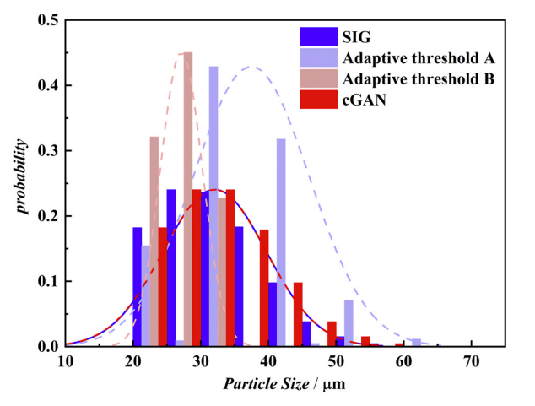
Figure 1 Place here the figure caption.

Equations
One blank line must be included above and below each equation.

$$\left[M\right]\left\{\overset{¨}{x}\left(t\right)\right\}+\left[C\right]\left\{\overset{˙}{x}\left(t\right)\right\}+\left[K\right]\left\{x\left(t\right)\right\}=f\left(t\right)$$ | (1)
$$M\overset{¨}{x}\left(t\right)+C\overset{˙}{x}\left(t\right)+\text{Kx}\left(t\right)=f\left(t\right)$$ | (2)
One Example of Table
Table 1 Specifications of the test section
Case No. | 1 | 2 | 3 | 4
d_{p}(mm) | 5 | 6 | 7 | 8
Length(mm) | 260.48 | 311.80 | 364.67 | 361.33
Width(mm) | 45 | 54 | 63 | 72
Height(mm) | 6.58 | 7.9 | 9.22 | 10.53
3. Results and Discussion
3.1 About Sub-Sections
Use this section to describe your results.

3.2 About Sub-Sections
You can change the title of this section, and you can include figures and tables.
4. Conclusions
Describe the main conclusions of your work in this section briefly.
Acknowledgements
The authors acknowledge the support from the National Natural Science Foundation of China (No. XXX).
References
[1] L. Chen, Handbook of Research on Advancements in Supercritical Fluids Applications for Sustainable Energy Systems, IGI Global, USA (2021). --book
[2] G. Liu, H. Cao, J. Xu, Solar evaporation of a hanging plasmonic droplet, Solar Energy, 170 (2018) 184-191. --article
[3] R. Zhang, L. Chen, Y. Kanda, A. Komiya, H.S. Chen, Asymptotic analysis for thermal-mechanical effects of CO₂ near its gas-liquid critical point with different approaches in thermophysical properties, The 17th International Heat Transfer Conference, August 14-18, 2023, Cape Town, South Africa. --conference proceedings

